ADA Question Bank for IAT-2

S. No | Problem Statement

Topic: - Topological Sorting

1 | Define topological sorting. Illustrate the topological sorting using DFS method for the following graph.  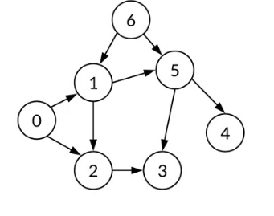
2 | Define topological sorting. Illustrate the topological sorting using DFS method for the following graph.  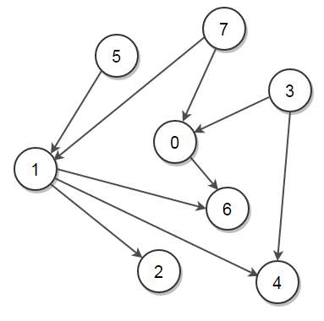
Topic: - Kruskal & Prims Algorithm
3 | Construct minimum cost spanning tree using Kruskal’s algorithm for the following graph.  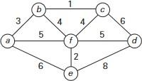
4 | Define minimum cost spanning tree. Write Prim's algorithm to find minimum cost spanning tree.
5 | Construct minimum cost spanning tree using Prim’s algorithm for the following graph.  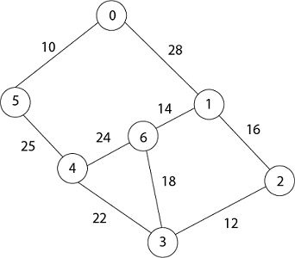

Topic: - Knapsack Problem statement
6 | Solve the following instance of greedy knapsack problem where n=4, m=10, p = (40, 42, 25, 12) and w = (4, 7, 5, 3)
7 | Find the optimal solution of the knapsack instance n=7, M=15, (P1,P2,…..,P7)=( 10,5,15,7,6,18,3) and (w1,w2,…..,w7)=(2,3,5,7,1,4,1)
8 | Consider there are three items, weight & profits is as given below: -
  i | W_{i} | P_{i}
  1 | 18 | 30
  2 | 15 | 21
  3 | 10 | 18

Topic: - Heap & Heap Sort
9 | Define AVL Trees. Explain its four rotation types
10 | Construct bottom-up heap for the list 2,9,7,6,5,8. Obtain its time complexity
11 | Sort the given list of numbers using heap sort: 2, 9, 7, 6, 5, 8.
Topic: - Dijkstra’s Algorithm
12 | Apply Dijkstra’s algorithm to find single source shortest path for the given graph by considering S as the source vertex.  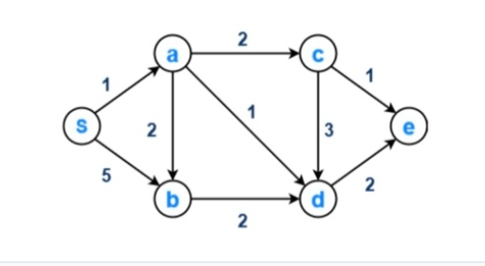
13 | Write an algorithm to find single source shortest path for a graph G whose edge weights are positive
Topic: - All pair shortest Path algorithm
14 | Apply Floyd's algorithm to find all pair shortest path for the graph given below.  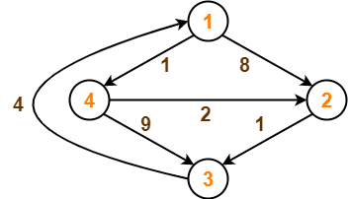
15 | Define transitive closure of a graph. Apply Warshall’s algorithm to compute transitive closure of a directed graph  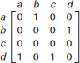
Topic: -Travelling salesman problem statement
16 | For the given graph, obtain optimal tour cost using dynamic programming.  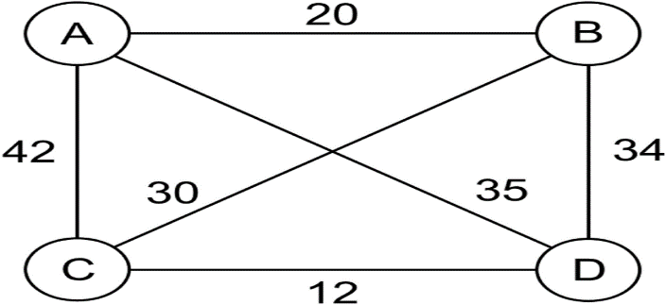

Topic: -Huffman Coding
17 | Obtain the Huffman tree and the code for the following data
  Characters | Frequencies
  a | 10
  e | 15
  i | 12
  o | 3
  u | 4
  s | 13
  t | 1
18 | What are Huffman Trees? Construct the Huffman tree for the following data.  Encode DAD-CBE using Huffman Encoding.
  Character | A | B | C | D | E | -
  Probability | 0.5 | 0.35 | 0.5 | 0.1 | 0.4 | 0.2
19 | Explain N Queen problem with an example
20 | Solve the given instance of the sum of subset problems s={3,5,6,7} and d=15. Construct a state space tree
21 | Draw the state space for the sum of subset problem of the instances= {5,7,8,10} and d=15
22 | Explain the class of NP- Hard and NP-Complete
23 | Explain LC branch and bound concept for knapsack problem.
24 | Explain the subset-sum problem with an example using the backtracking method.
25 | What is the central principle of backtracking? Apply backtracking to solve the below instance of sum of subset problem S = {5, 10, 12, 13, 15, 18} d = 30
26 | Explain the classes of NP-Hard and NP-Complete problems
27 | Apply branch and bound to solve the knapsack problem with n =4, V = {10, 10, 12, 18}, w = {2, 4, 6, 9} and W = 15.
28 | Write Horspool algorithm for string matching. Find the pattern BARBER in the text: JIM_SAW_ME_IN_A_BARBER

